Isabel Finkbeiner, Vedant Nilabh, Ahmad Saeed

Professor Huskinson

CS 1340

Final Project: Report

Equity and Profitability: Reimagining The City of Dallas’s Budget

I. Introduction

The city of Dallas’s population consists of individuals from many ethnic, and socioeconomic backgrounds. When analyzing this city, it is important to factor these variables into play. When the city conducted a market value analysis in 2017 they grouped different segments of Dallas into various market types based on socio-economic ranking. However, they did not consider the relevance of different demographic groups, specifically groups of different races and ethnicities. This creates a key issue because of urban planning as well as the fact that the legacy of practices like redlining and “white flight” to the suburbs create effectively segregated neighborhoods in American Cities for minority and immigrant groups, which has a strong known effect on standard of living. Thus, when looking at the issue of market value and development within the city of Dallas, the consideration of different demographic groups is paramount.

II. Data Description

The three data sets utilized in this study are the City of Dallas Expenses, Market Value Analysis, and Dallas County Block Groups with Appraisal Rollouts. The City of Dallas Expenses data examined the city’s expenses and budget for the fiscal years of 2016 and 2017. The data set included the specific appropriation of the funds, the specific services the funds would be utilized for, the expenditure classification, the current budget, and the expenses. Of particular importance to this study were the columns of appropriation, service, current budget, and expenses as they indicate where the city allocated its money during the years 2016-2017. The Dallas Market Value Analysis data analyzed the elements of Dallas’s real estate market with the city broken up into small segments to review. The columns that proved the most useful for this study included Median Sales Price, Percent Foreclosure, Percent New Construction Permit, Percent Code Violations, Percent Rehabilitation Permit, Percent Public Subsidy, and Population Density. The Dallas County Block Groups with Appraisal Rollouts data set measured the population density, the ethnic composition of the block, as well as other statistics including the age composition, gender distribution, and percent of rented and owned homes to name a few. The columns utilized for this study included population density and the specific populations of different racial and ethnic groups within each block group such as white, black, Asian, Hispanic, and the minority population. The above-mentioned data sets were all obtained from Dallas Open Data, which is a centralized resource that provides most of the Dallas city data. The intention of the Dallas Open Data portal is to provide citizens with a transparent, detailed view of the data published by the city. By performing a regression and creating plots for the data sets, we may analyze how we can improve the city of Dallas.

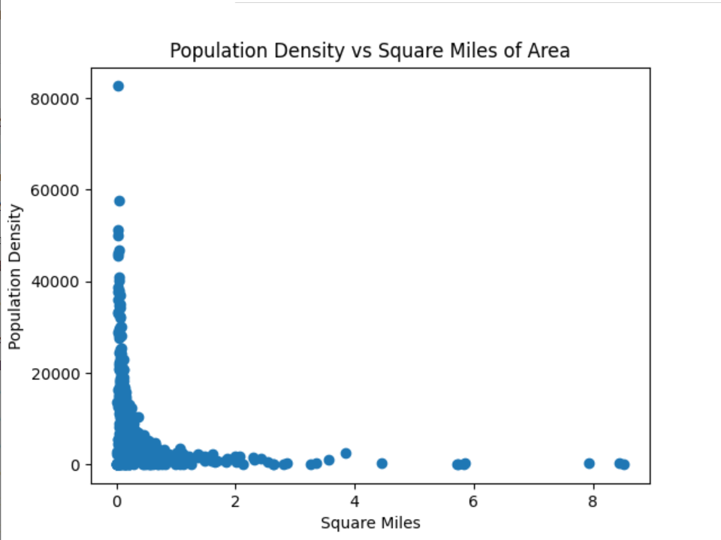

|  |
| --- |
| This scatter plot visualizes the population density in areas of different size. It conveys the idea that smaller areas are typically packed with more people. (NH_Dallas_County csv) |

`

|  |
| --- |
| This scatter plot visualizes the distribution of races throughout specific areas of Dallas. The general trend that is shown is that areas with more of a white population tend to have less minorities and vice versa. |

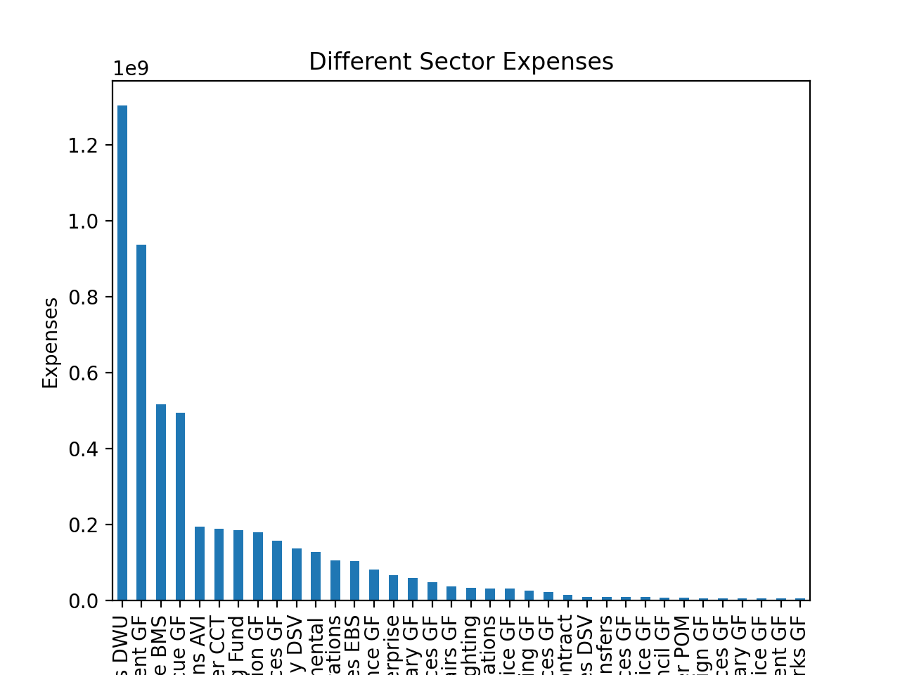

|  |
| --- |
| The top 4 categories in spending for the city of Dallas in 2017 were water utilities, police department, debt services, and fire rescue. The last bar on this chart is Public Works, which includes public infrastructure such as transportation. |

III. Inferences and Justification

The demographic breakdown in the city of Dallas is important to discuss, and, based on our census blocks data, is 27.6% White and 72.4% Minority/Nonwhite, with the two most common groups within that being Hispanic and Black, which make up 43.8 % and 24.8% of the population respectively. These 3 groups are by far the largest in the city of Dallas, with the Hispanic and Black Populations making up more than 68.6% of the City’s Population and approximately 95% of its minority population, which makes up 72.4% of the city’s total population. The regression we created predicts the Percentage Minority, which is just the inverse of Percentage White and made up mostly by Black and Hispanic populations, based on Median Sales Price, Percent Foreclosure filings, Percent permits for new construction, Percent code violations, Percent permits for rehabilitation, Percent public subsidy, Population Density, and the Total Value of the block calculated based on tax appraisal data. The Sales Price and Total Value are a good indication of the property values of different blocks, The Percent code violations Percent Foreclosures are good indications of relative condition of blocks analyzed, as they provide information on whether residents are being able to hold onto their homes and if those homes are of livable condition. The Percent permits for new construction and for rehabilitation are indicators of relative investment and indicate whether investment is being made into blocks analyzed. Finally, the Percentage Public Subsidy gives a clear indication of whether residents are being able to sustain themselves and what blocks are requiring more government investment through subsidy to sustain, and Population Density relates to how concentrated areas are based on population distribution. Based on this regression, Median Sales Price, Total Value, Percent permits for new construction, and Percent Permits for Rehabilitation had negative coefficient values in relation to Percent Minority, while Percent Foreclosures, Percent Code Violations, Percent Public Subsidy, and Population Density had positive coefficient values in relation to Percent Minority. This means that, not only are higher minority areas generally lower value with lower property prices, but they also have higher population densities, code violations, and percent foreclosures, indicating significantly lower levels of access to quality housing relative to white people, as these values would be the opposite if run against percentage white people (the definition of minority). Additionally, the higher rates of public subsidy are the way that the city and others have chosen to support these groups, rather than facilitating the building of new or rehabilitated housing or infrastructure, meaning the subsidies aren’t creating a net positive for these higher density and minority communities. Thus, we can conclude that the urban, lower value areas are disproportionality high minority, and the efforts to economically stimulate these areas have so far been insufficient, as they aren’t addressing the issue through improvement, but through subsidies that only serve to maintain the condition of these areas. In addition to investing in better quality housing in these areas, it is also essential to consider other important types of infrastructure that can better connect these higher density and minority areas of lower value to higher value areas, and thus facilitate more equitable access to opportunities for these groups and areas, a place where the city of Dallas and its DART system has failed tremendously.

**Regression predicting Percentage Minority based on variables**

|  |  |
| --- | --- |
| Model intercept | 68.68026932084308 |
| MdSalesPr | -15.022244774318665 |
| PFclOO1517 | 1.6340361662648473 |
| PPermNCUnt | -0.15016021408547942 |
| PCVLnRsPr | 5.862788614086851 |
| PrehabPerm | -5.4680954321726585 |
| PPubSubAll | 5.1976946644924045 |
| POPDENS | 3.0514523874989434 |
| TotalVal | -3.957133225861397 |

IV. Project Cost Estimate

One of the most inefficient public transportation systems across the country belongs to the city of Dallas, Texas. DART, Dallas Area Rapid Transit, exemplifies one of the problems plaguing transportation systems in that its poorly designed routing system is largely unhelpful to city residents living in densely populated areas. Individuals who live in those densely populated areas and who rely on public transportation systems are often part of minority groups. Dallas’s transportation problem extends beyond economic inefficiency as it also continues patterns of segregation in urban planning that extend back to the middle of the twentieth century. The issue at hand is clear, there is a problem with the fair distribution of resources given based on race. To combat this problem, we propose to fix the current DART transportation system. We desire a transportation system that favors densely packed areas rather than areas with a white majority and less population. After analyzing our budget and reviewing multiple other projects like this, we have concluded that amending the railroads would cost close to $331,618,650. By aggregating costs to optimize the existing transportation system (buses and railroads), we concluded the total cost, as an initial investment, would be $496,618,650. This exact number was determined by taking the current rate of optimizing and adding an existing railroad system ($7,320,000) and the square miles that the railroad will extend (45.3 miles) and then also adding on the amount it would take to add and optimize the DART busing system ($150,000,000). Our budget has room for this project if we can spread it over multiple years. This solution is not only the fair thing to do, but it will also be profitable in the long term. Most of the people who use the DART system are minorities. If we make DART even more accessible by reaching out to densely populated areas, we bring in bigger profits. By amending the current DART transportation system, we must target a bigger percentage of the population Texas may take a step towards equality and profitability. Furthermore, this is just a recommended initial action, and more steps should be considered and taken to best ensure the future of DART and the many people who rely on it for their transportation needs..